EXPERIMENT-10
10. A robotic arm transfers stacked containers while following movement constraints. Solve the Towers of Hanoi. Generate the optimal sequence of moves.
Problem

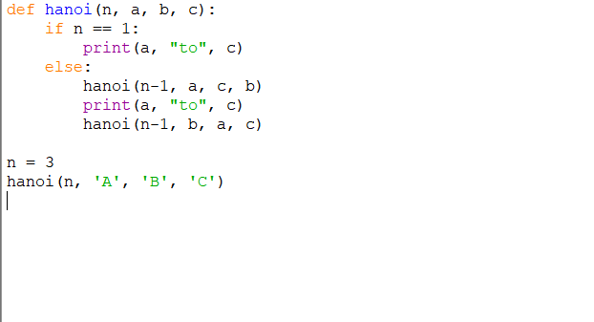
PROGRAM:

OUTPUT:
